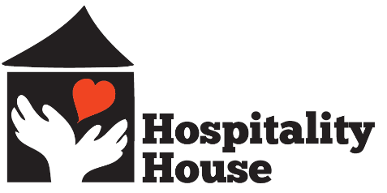

How To Remember Hospitality House In Your Will

One advantage of giving by will is the flexibility it offers. You can give all, or a portion of your estate to Hospitality House and restrict it if you have a program. If you choose to restrict the purpose of your bequest, please notify an official at Hospitality House to ensure that your wishes can be carried out. The following are five of the most popular forms that bequests can take:

A fixed amount of money or a designated property:
“I give to Foothill House of Hospitality, located in Grass Valley, California, cash in the sum of $______________.” (Or describe the real or personal property, including exact location).

A percentage of the estate:
“I give Foothill House of Hospitality, located in Grass Valley, California, ________% of the residue of my estate.”

A residual bequest:
“All the residues of my estate, including real and personal property, I give to Hospitality House, located in Grass Valley, California.”

A double-purpose bequest:
You can provide for yourself and/or one other person with income for life through a special gift to Foothill House of Hospitality. You can do this by establishing a charitable trust through your will. Upon your death, the trust pays income to the person you designate. After that person’s death, whatever remains in the trust passes to Foothill House of Hospitality. Please call Ashley Quadros, Development Director, at 530.615.0852 for further information.

A bequest to a specific program:
If you wish to have your bequest applied to a specific program, simply add “for the benefit of (name of the program)” to the language suggested above. For a complete list of Hospitality House programs, please visit our website, hhshelter.org, or call Ashley Quadros at 530.615.0852 for additional information.

It is always best to consult an attorney when preparing any legal document.

